**MINI PROJECT-I**

**(2020-21)**

**E-commerce Webpage**

**MID-TERM REPORT**

**Institute of Engineering & Technology**

**Team Members**

Avni Mishra

(181500165)

Saumya Singh

(181500634)

Shreshtha Tola

(181500688)

# Supervised By

**Mr. Mandeep Singh**

**Technical Trainer**

**Department of Computer Engineering & Applications**

|  |
| --- |
| **Contents** |
| **Abstract 3** |
| **1. Introduction 4** |
| 1.1 General Introduction to the topic 4 |
| * 1. About front-end technology 4   2. Languages Used 5   3. Hardware and Software requirements 6 |
| **2.Problem Statement 7** |
| **3. Objective 8** |
| **4.Progress till Date 9** |
| **5.Software Design with Use Case Diagram 10** |
| **6.Some Screenshots 11** |
| **7.References 19** |

# ABSTRACT

The main purpose of this project is to create an Online product selling Website that allows users to buy item based on price, quantity and its authenticity. The selected items are displayed in an attractive format and the buyer can simply buy those items white sitting at home. The Administrator will have additional functionalities when compared to the common user. Another objective of this project is to promote local manufacturers; small businessman can contact us to get their products on display so as to get them on the mainstream online market.

This project is an attempt to provide the advantages of online shopping to customers of a real shop. It helps buying the products in the shop anywhere through internet by using an android device. Thus the customer will get the service of online shopping and home delivery from his favorite shop. This system can be implemented to any shop in the locality or to multinational branded shops having retail outlet chains. If shops are providing an online portal where their customers can enjoy easy shopping from anywhere, the shops won’t be losing any more customers to the trending online shops such as flipcart or ebay. Since the application is available in the Smartphone it is easily accessible and always available.

# INTRODUCTION

* 1. **General Introduction to the topic :**

E-commerce is fast gaining ground as an accepted and used business paradigm. More and more business houses are implementing web sites providing functionality for performing commercial transactions over the web. It is reasonable to say that the process of shopping on the web is becoming commonplace. The objective of this project is to develop a general purpose e-commerce website. Online shopping is the process whereby consumers directly buy goods or services from a seller in real-time, without an intermediary service, over the Internet. An online shop, e-shop, e-store, internet shop, web shop, online store, or virtual store evokes the physical analogy of buying products or services at a bricks-and-mortar retailer or in a shopping centre. The process is called Business-to Consumer (B2C) online shopping.

 E-Commerce Website is a virtual store on the Internet where customers can browse the catalog and select products of interest. The selected items may be collected in a shopping cart. At checkout time, the items in the shopping cart will be presented as an order. At that time, more information will be needed to complete the transaction. Usually, the customer will be asked to fill or select a billing address, a shipping address, a shipping option, and payment information such as credit card number. An e- mail notification is sent to the customer as soon as the order is placed.

Online Shopping is rising day by day in India. Because India is the country where computer user's are increasing day by day so as the online shopping trends are also increasing. This project covers the online selling of cosmetics, fashion accessories, watches etc. The project shows the product category and then product details. From the product details, the product can be added to cart and can be bought.

# About front-end technology :

The website’s **front end** is everything we can see and can interact with using a browser. So, creating this visual part is called front-end development. The front end stack is made up of many different languages and libraries. While these vary from application to application, there are only a few generic languages understood by all web browsers. These three main front-end coding languages are HTML, CSS and JavaScript. Together, they create the underlying scaffolding that web browsers use to render the web pages that we interact with every day. All other libraries and front-end engineering are built upon these three main languages, which makes them must-have skills for any front-end developer. The initial UX design is the blueprint. HTML is the basic structure of the house. The CSS is the paint, fixtures, and other aesthetic decisions that make the house look attractive. And finally, JavaScript is the inner workings of the house (lights, heating, water) that we, the owner or renter, use and enjoy.

# Languages Used:

**1.HTML**

HTML (or Hypertext Markup Language) is a computer language designed to create websites that later can be explored by anybody who accesses the Internet. HTML is normally employed to structure a web document. It defines such elements as headlines or paragraphs and enables embedding images, video, and other media.

**HOW IT WORKS?**

* ***Hypertext***is the way by which we travel across the web by clicking hyperlinks – specific texts taking you to other pages. Hyper means it’s non-linear, which allows for moving to any other place, as there is no predefined order to do so.
* ***Markup***determines the qualities that HTML tags apply to the text inside them. Tags mark it as a particular type of text.
* As **a *Language***, it holds code words and syntax like any other language.

**2.CSS**:

CSS (or Cascading Style Sheets) is a style sheet language. It’s applied to define how HTML

elements are supposed to be presented on a webpage in terms of design, layout, and variations

for diverse devices with different screen sizes. CSS masters the layout of numerous different

web pages at a time.

**HOW IT WORKS?**

* To communicate with HTML, CSS uses **selectors**. A selector is the part of CSS code defining which HTML piece the CSS styling will impact.
* A **declaration** contains properties and values that are employed by the selector.
* **Properties** define font size, color, and margins. Values are the settings for these properties.

## 3.Bootstrap 4:

* Bootstrap is a free front-end framework for faster and easier web development
* Bootstrap includes HTML and CSS based design templates for typography, forms, buttons, and tables, navigation, modals, image carousels and many other, as well as optional JavaScript plug-in.
* Bootstrap also gives us the ability to easily create responsive designs

**WHAT IS RESPONSIVE WEB DESIGNS?**

Responsive web design is about creating web sites which automatically adjust themselves to look good on all devices, from small phones to large desktops.

## 4.JavaScript:

JavaScript is a lightweight, interpreted programming language. It is designed for creating network-centric applications. It is complimentary to and integrated with Java. JavaScript is very easy to implement because it is integrated with HTML. It is open and crossplatform. JavaScript is the most popular programming language in the world and that makes it a programmer’s great choice. Once you learnt JavaScript, it helps you developing great frontend as well as back-end software using different JavaScript based frameworks like jQuery, Node.JS etc.

# Software Specification:

* + - Technology Implemented : Front-end, Back-end Technology
    - Tools Used : Html, Css, Javascript, Bootstrap
    - User Interface Design : Visual Studio(Version 1.48)

# Hardware Requirements:

* + - Processor : intel i3
    - Operating System : Windows 10
    - RAM : 8GB
    - Hardware Devices : Computer System
    - Hard disk : 1 TB

# Problem Statement

Many-a-times, we have seen that people want to buy products but due to some reasons cannot go physically to the shops to buy them. And since this is a pandemic going on so people really prefer to have the stuff delivered rather than going to the shop. Similarly, the small businesses are having problem in sales due to this pandemic. So, this E-Shopping website will act as a bridge between the stuck at home public and their urge to shop as well as a helping hand towards the local businesses to expand their reach to the online platforms as well.

# OBJECTIVE

It’s extremely important to be able to respond to client needs in the most effective and timely manner whenever the customer have a yen to see our business online and ought to have instant access to our products. Hence, the objective of this project intends to ensure customer satisfaction during the harsh circumstances and to make sure that they do not lack in any aspect on their indelible vivid day**.**

This also eliminates the time wasted by the customers on surfing, as it takes a lot of time to switch between various shopping sites to get all the party supplies that they desire. Hence, it provides everything encircling parties at one stop.

# PROGRESS-

* + - * Created the Html structure of the webpage.
      * Created the following templates regarding e-shopping website-
        + Template for Home Page
        + Products Available
        + Template Login/Sign Up
        + Template for contact
      * Designed using CSS
      * Added additional features like slider images bar.
      * Working on add to cart and proceed to buy section .

# SOFTWARE DESIGN WITH USE CASE AND SEQUENCE DIAGRAM

**Use case diagram for customer-**

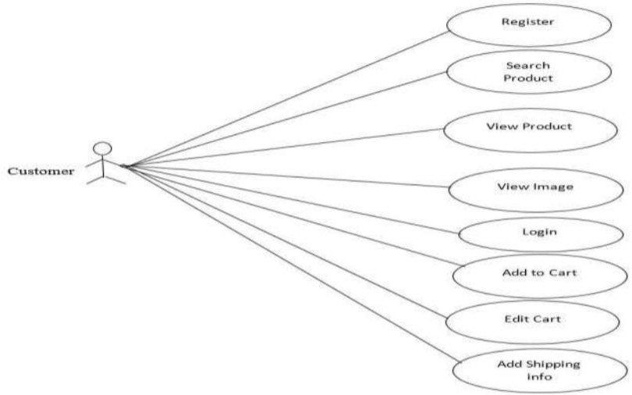

**Sequence Diagram**

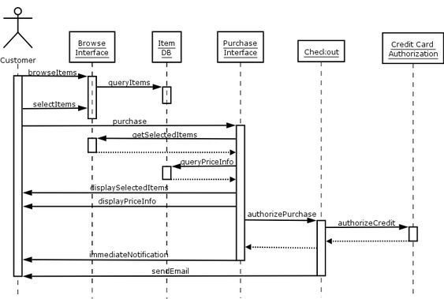

# SOME SCREENSHOTS

**Home page :**

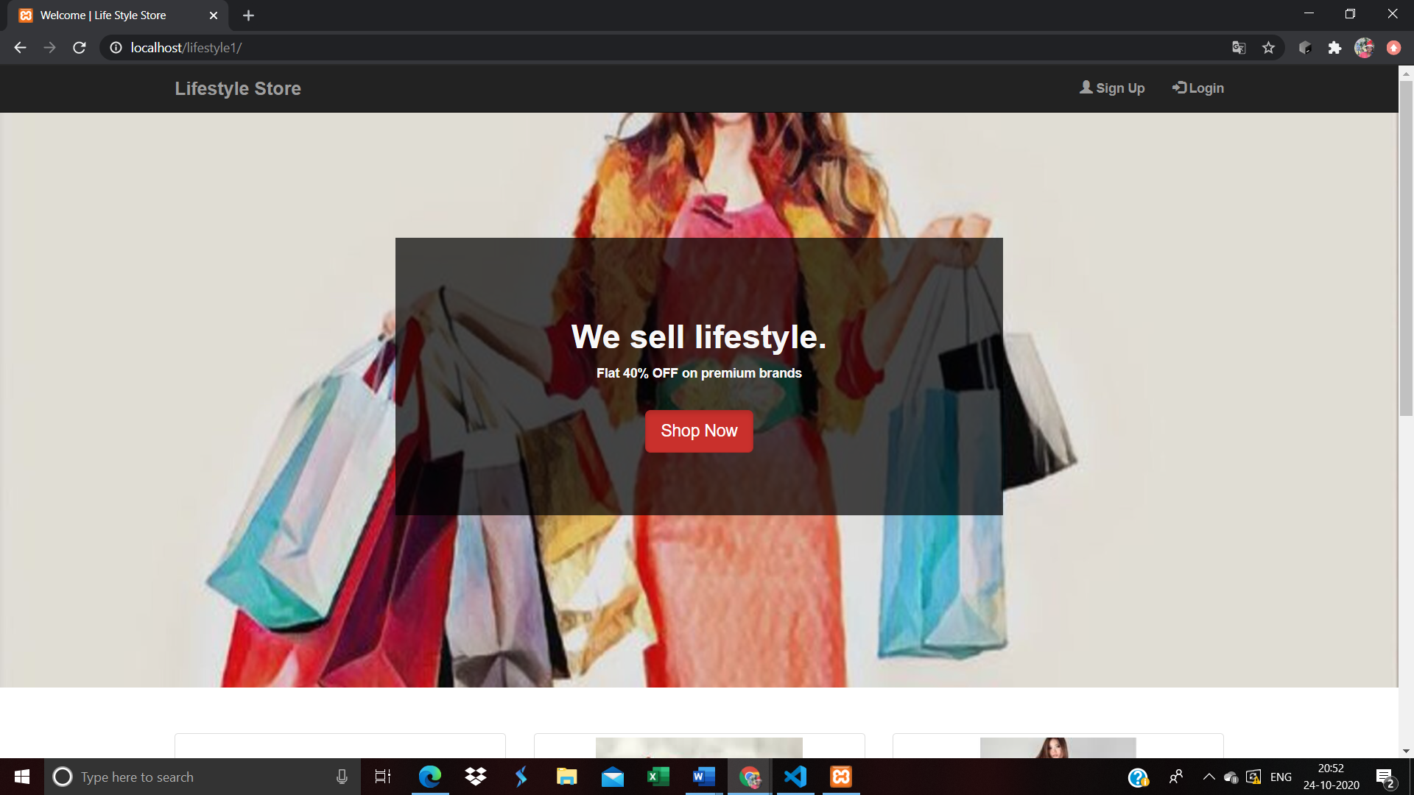

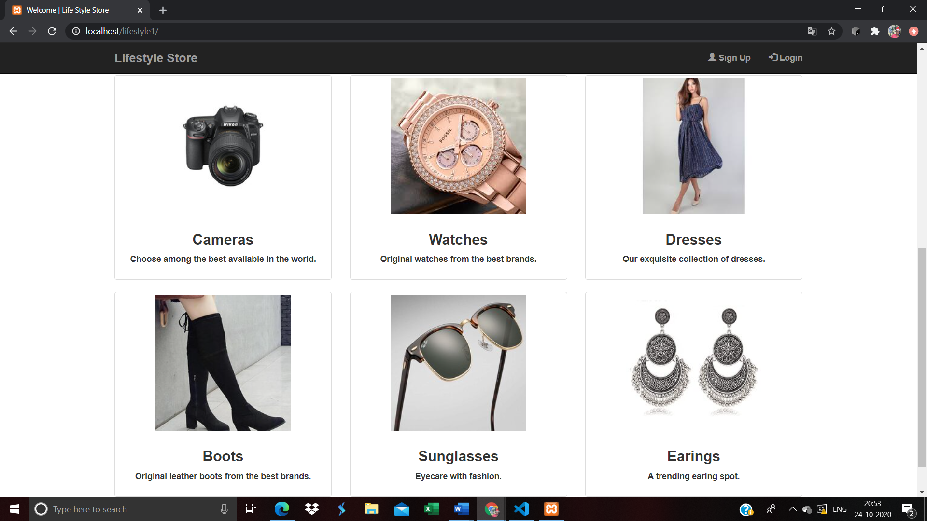

**If user Sign up with the registered email he/she will get an error**

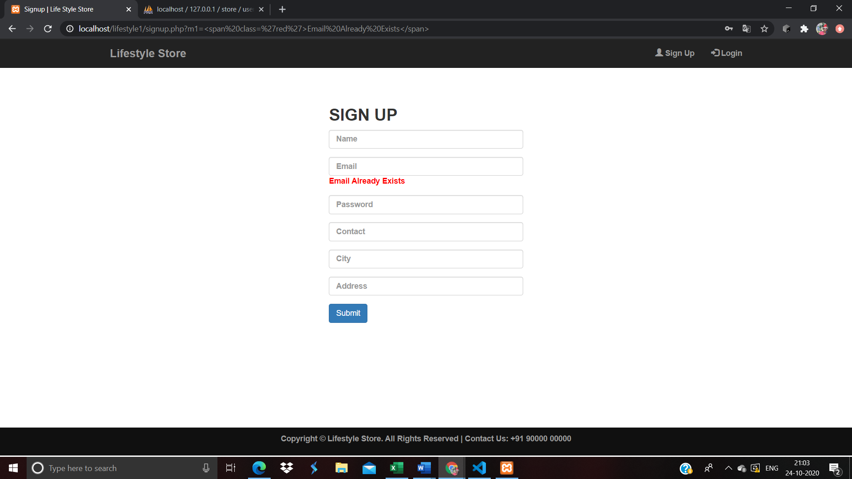

**After user sign up with all his credentials then the data is stored in the database**

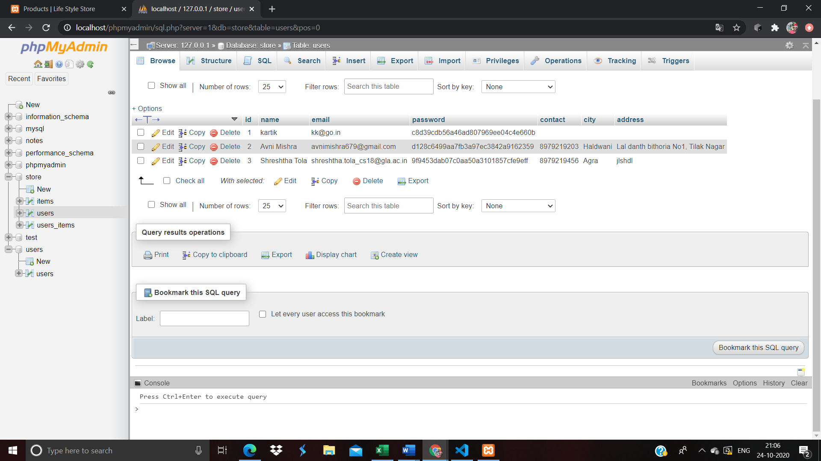

**If user tries to login without creating an account, then he will be requested to register/sign up** 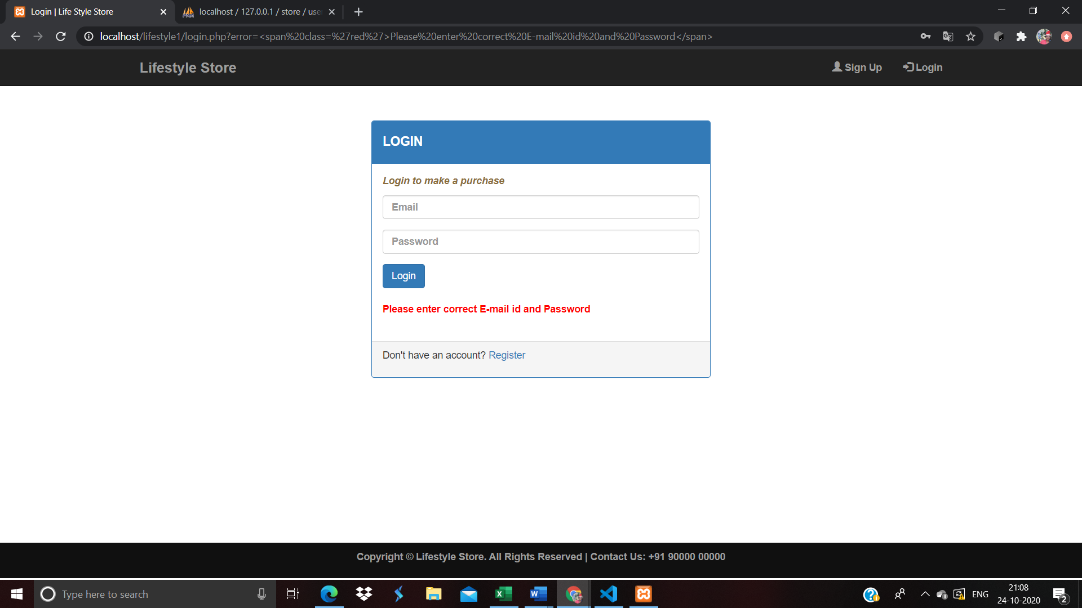

**After successful sign up and login the user/users will be redirected to the product page where they will able to find products of their choices and would be adding them to the cart, and if fully satisfied then proceeding for its purchase.**

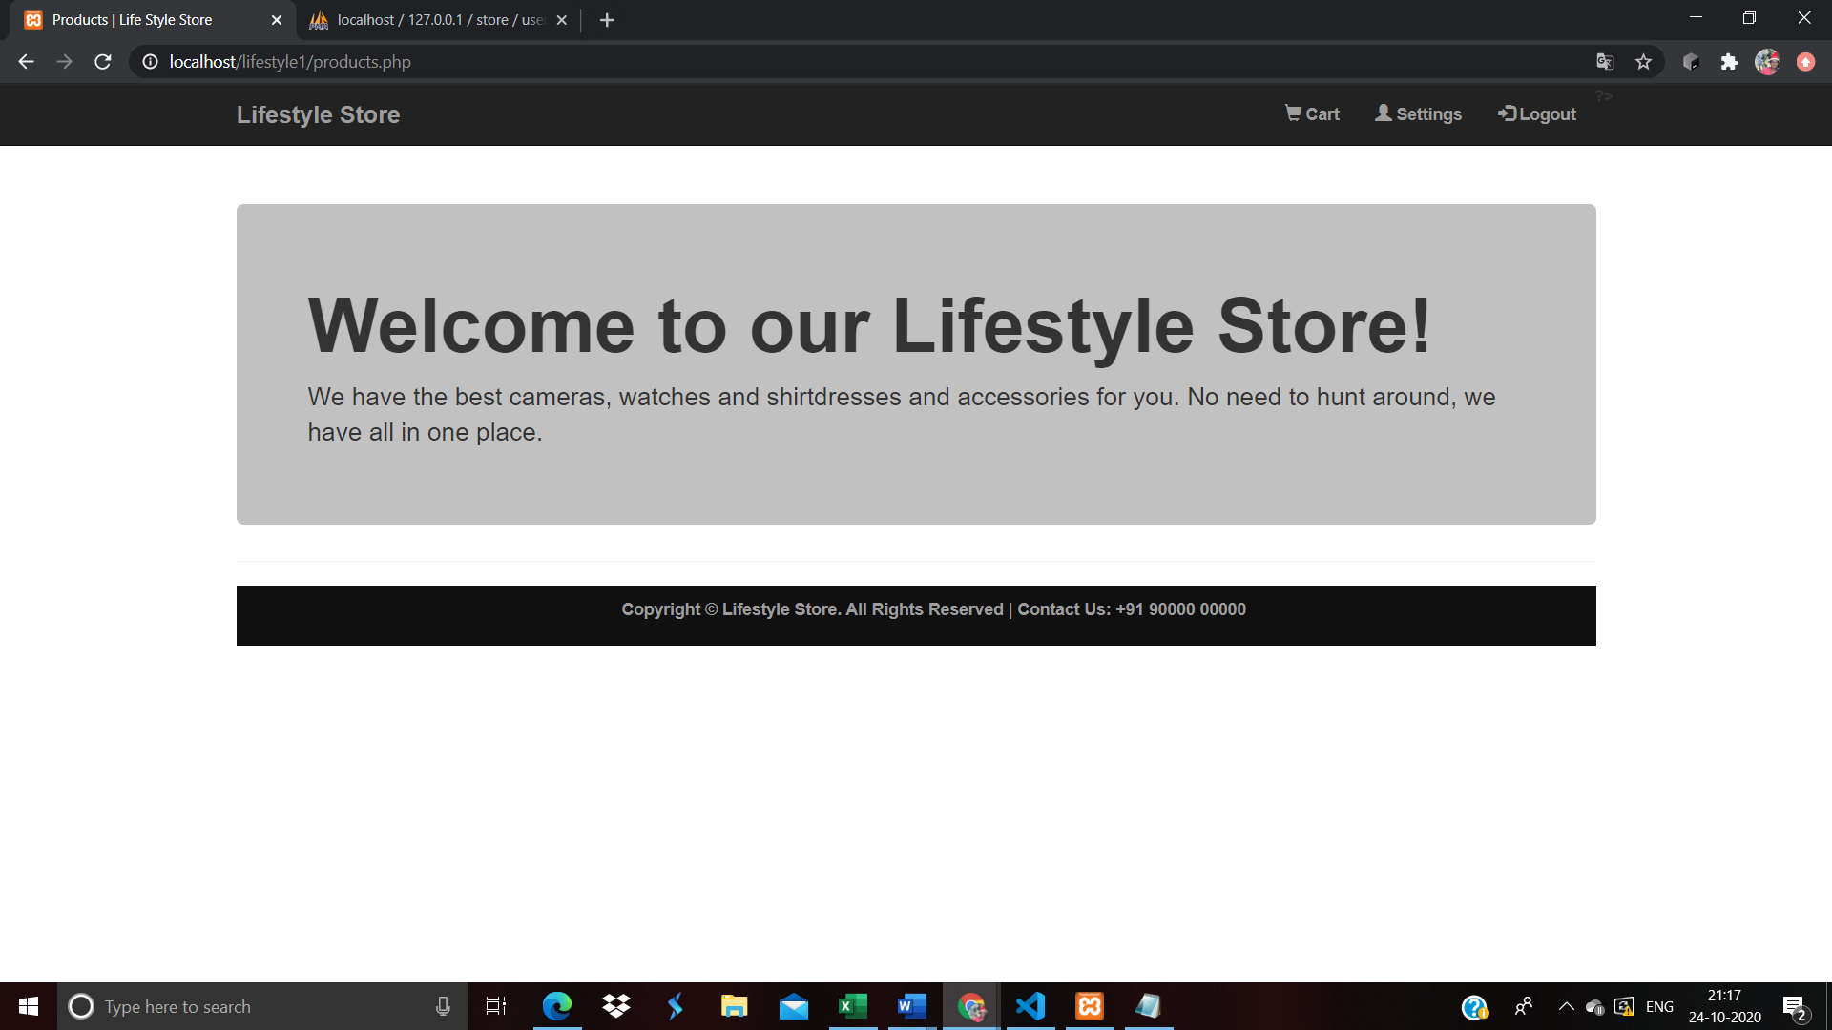

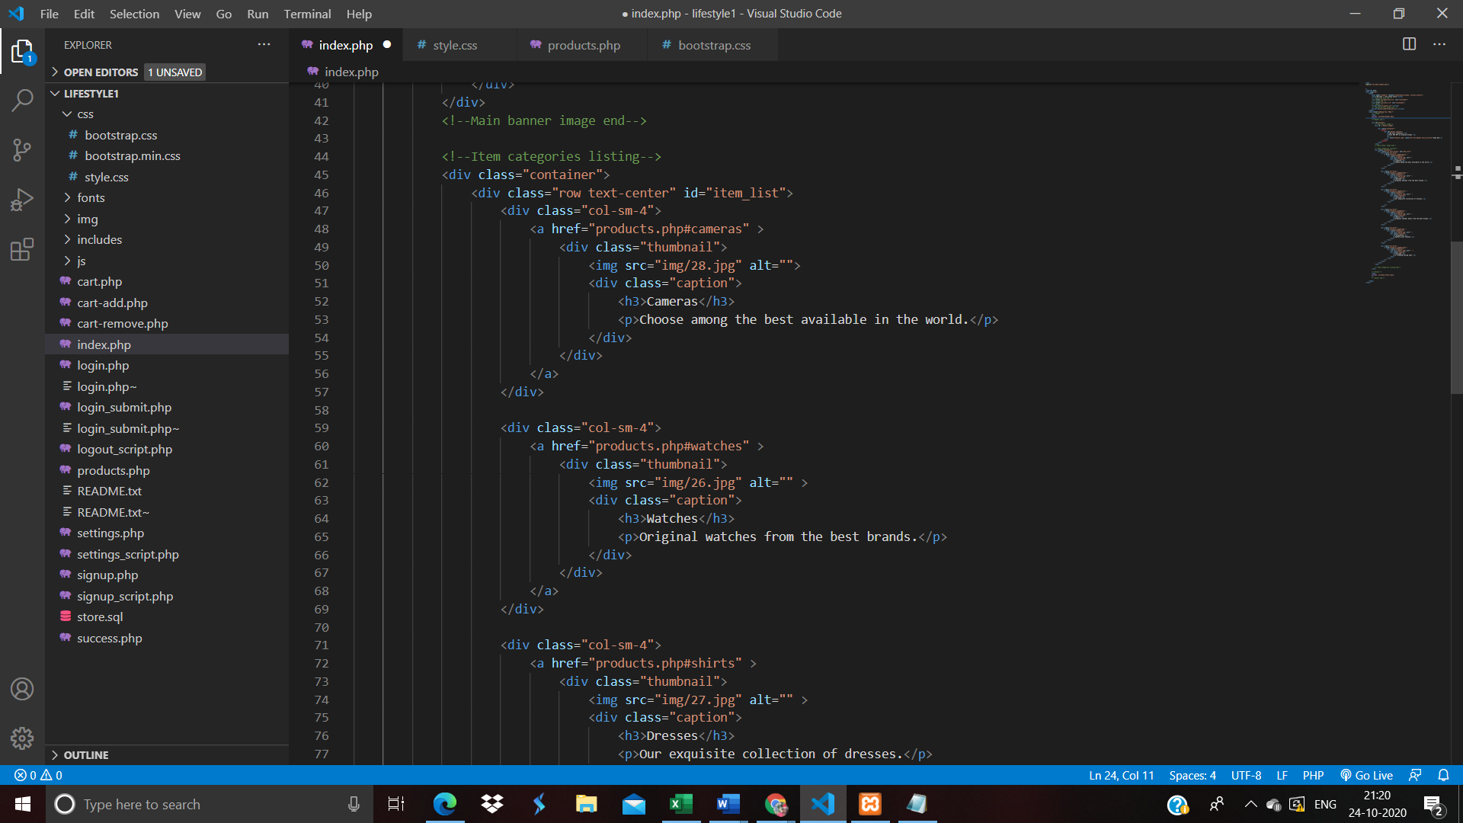

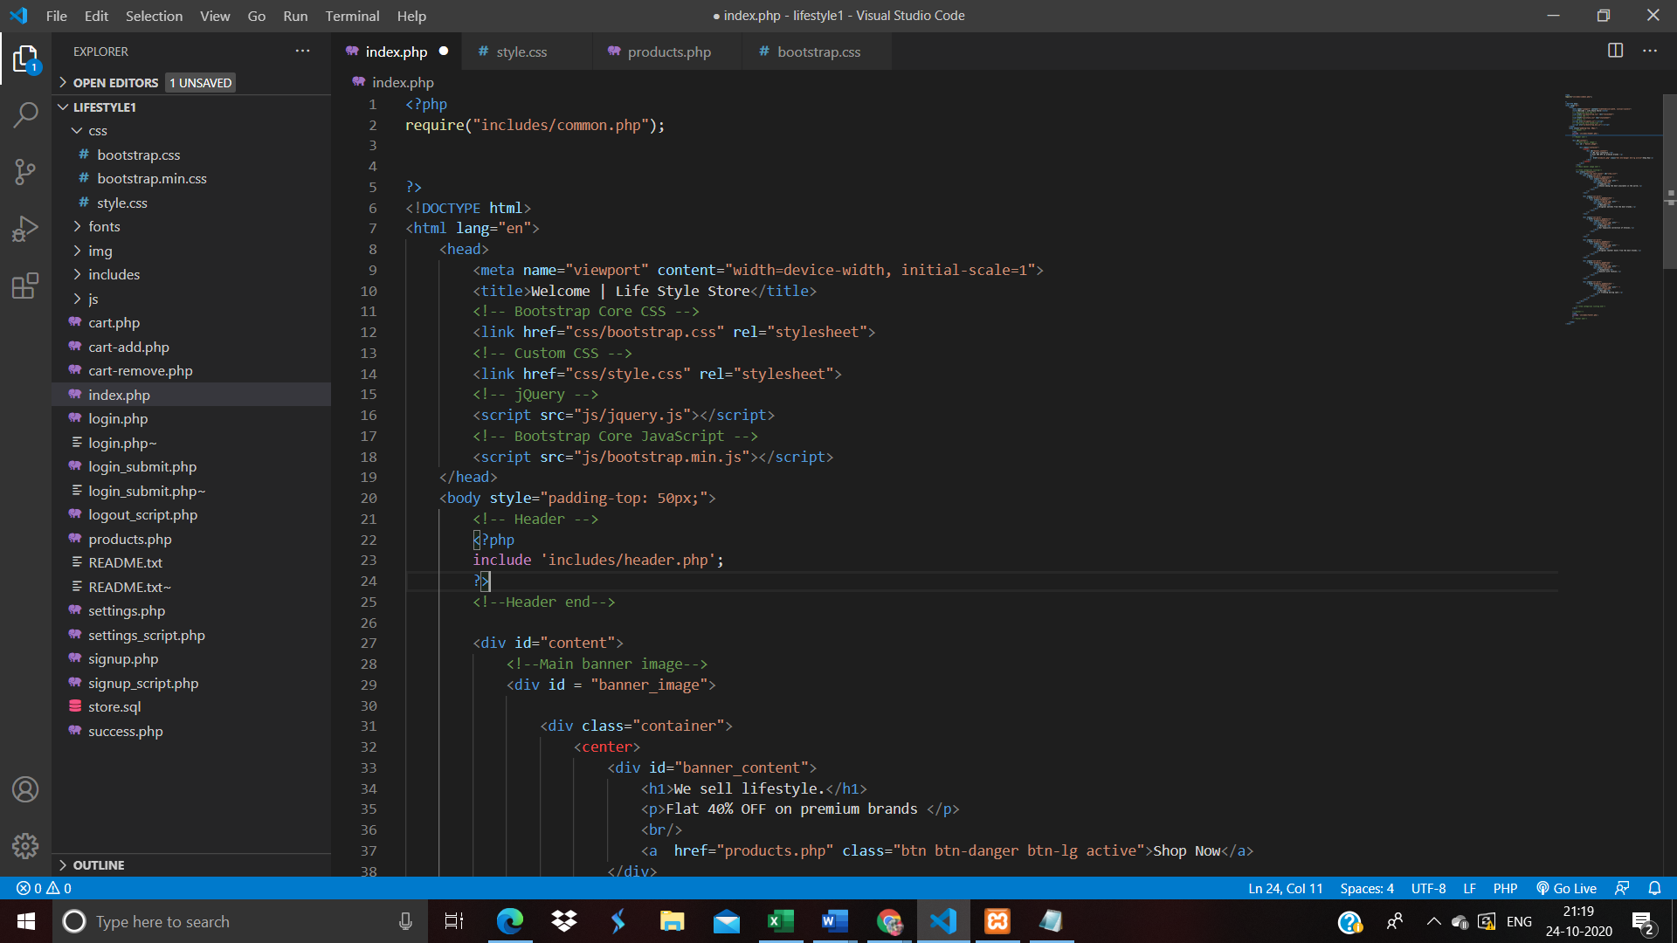

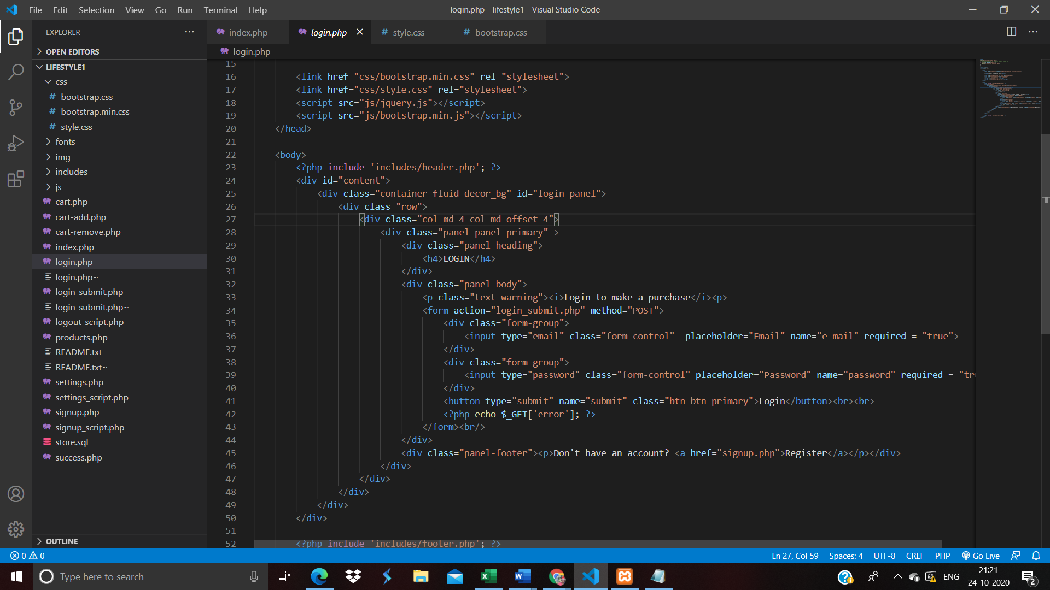 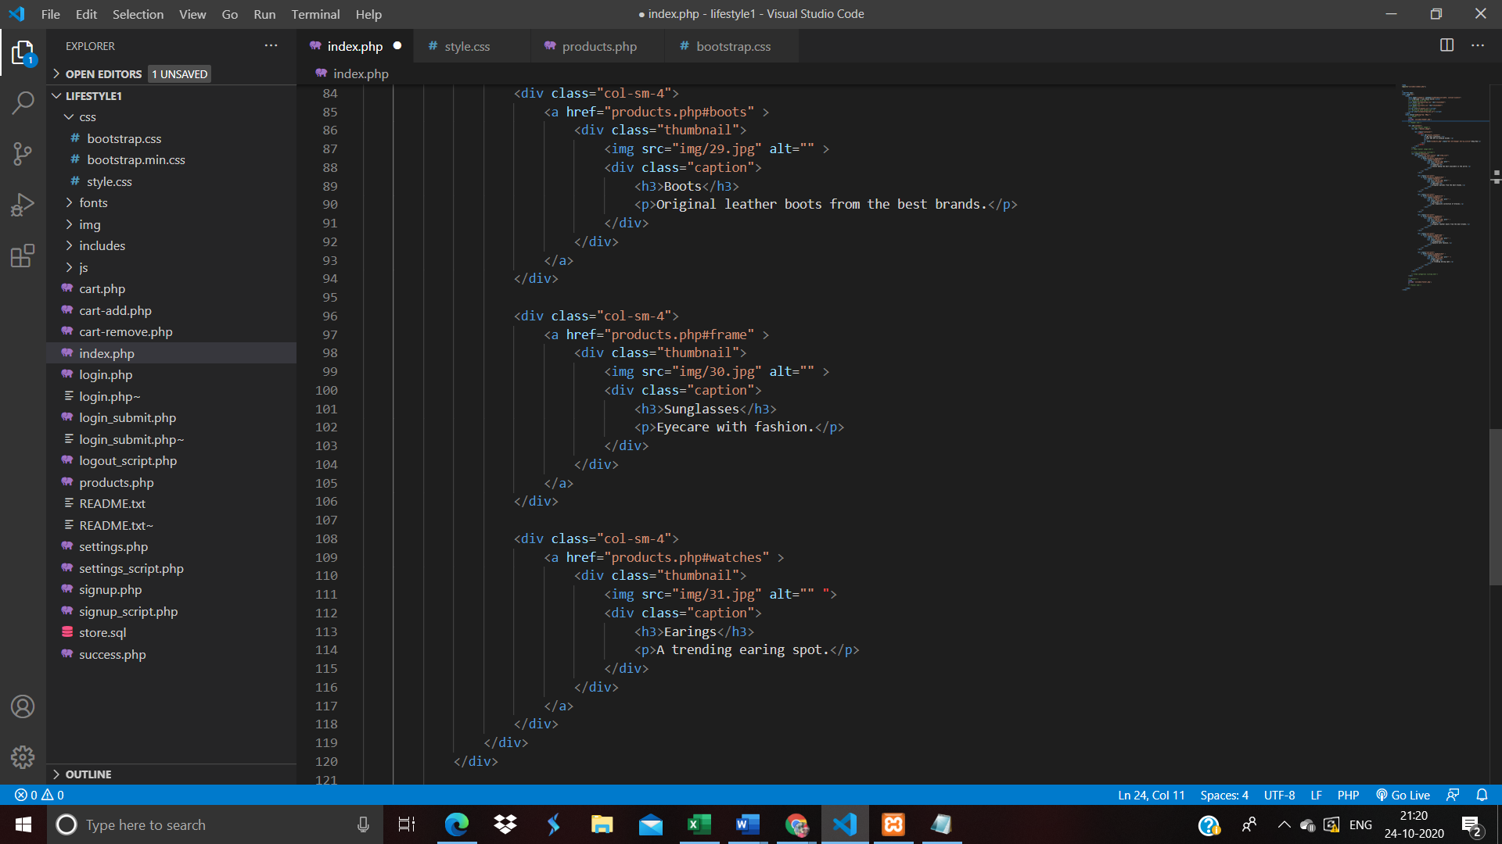

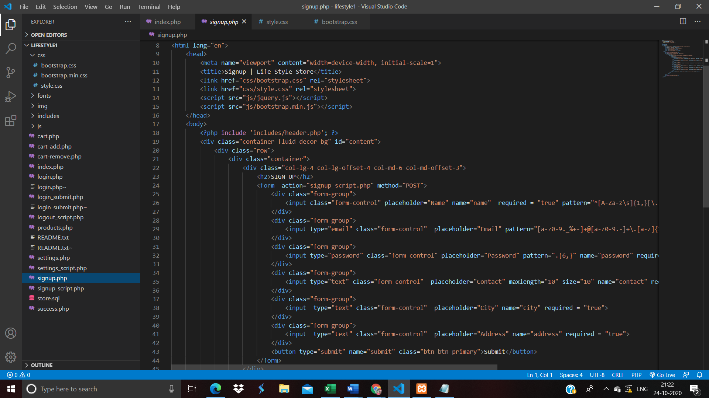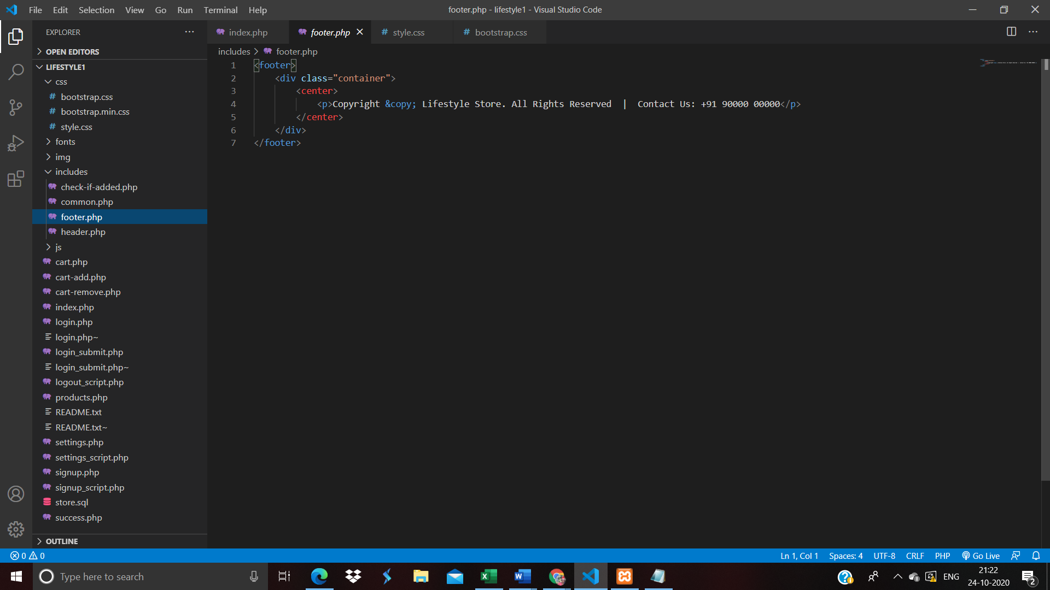

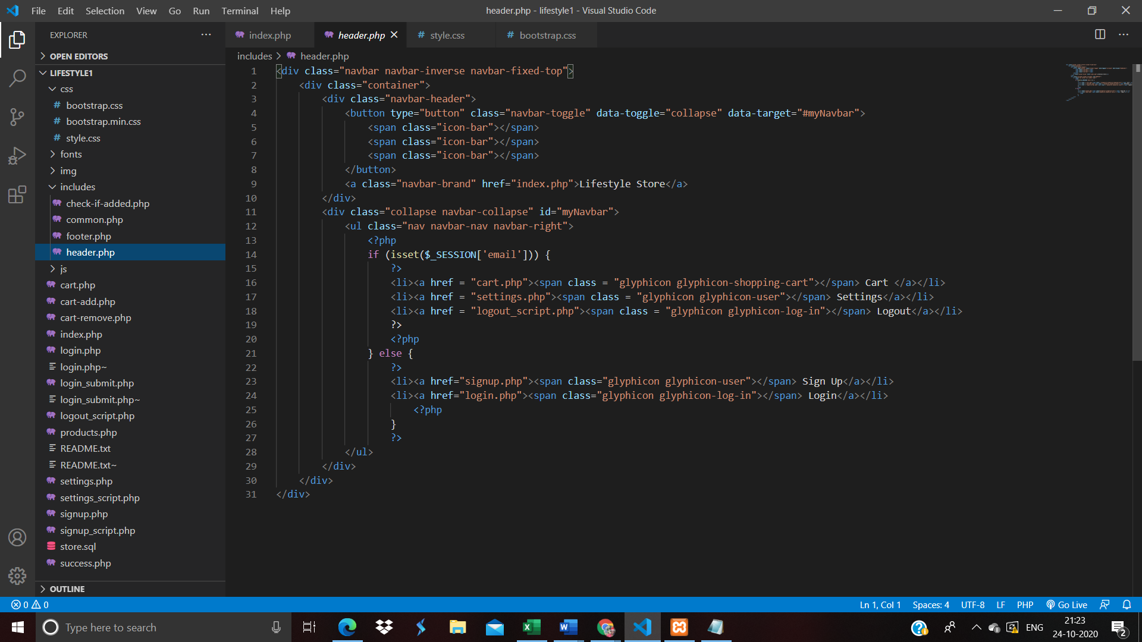 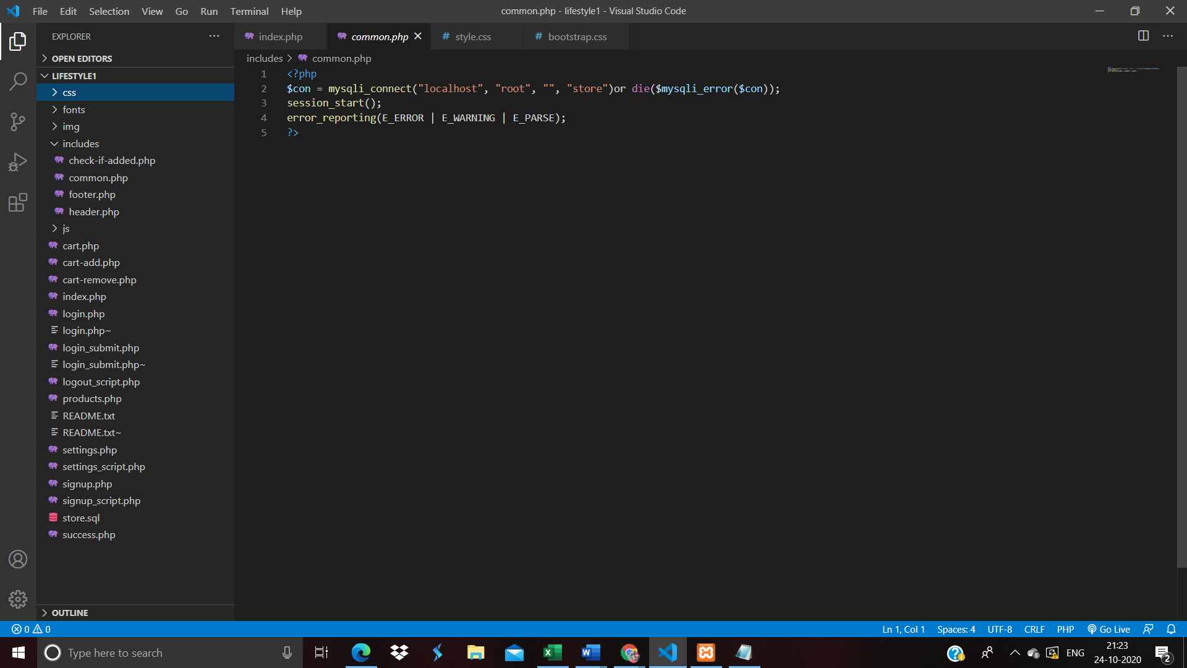

**REFERENCES**

<https://www.w3schools.com/html/>

<https://brainstation-23.com/ecommerce-web-development/>

[https://www.youtube.com/watch?v=6mbwJ2xhgzM&list=PLu0W_9lII9agiCUZYRsvtGTXdxk](https://www.youtube.com/watch?v=6mbwJ2xhgzM&amp;list=PLu0W_9lII9agiCUZYRsvtGTXdxkzPyItg) [zPyItg](https://www.youtube.com/watch?v=6mbwJ2xhgzM&amp;list=PLu0W_9lII9agiCUZYRsvtGTXdxkzPyItg)